**Term Project Report**

Name: Atharva Khaire

BUID: U15258568

Course: Designing and Implementing a Data Warehouse (CS 689 O2)

**Title**: Delivery Centers Data Warehouse

**Data Sources**:

Source 1: Brazilian Delivery Center Dataset

Link: <https://www.kaggle.com/datasets/nosbielcs/brazilian-delivery-center>

Description:

1. Channels: The marketplaces (sales channels) where the products and food of the merchants are sold.
2. Deliveries: The deliveries made by the partner couriers.
3. Drivers: The couriers who work with the centers. Every time an order is processed, they are stationed in the hubs and are in charge of delivering orders to customers' houses.
4. Hubs: The order distribution centers, or hubs, are where deliveries are sent out from.
5. Orders: The purchases made through the Delivery Center platform.
6. Payments: The payments made to the Delivery Center.
7. Stores: Data about the retailers. They advertise their products (goods and/or food) on marketplaces by using the Delivery Center platform.

Initial Flat Table:





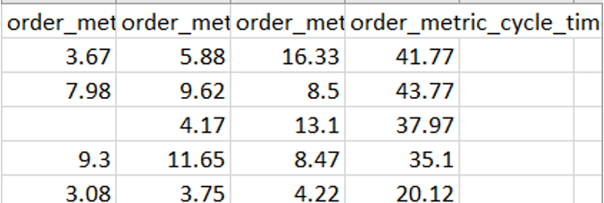

Source 2: Brazilian Cities

Link: <https://www.kaggle.com/datasets/crisparada/brazilian-cities>

Description:

* City
* State
* Capital
* Population

Note: There are more attributes in the dataset but we will be taking into account only the above four.

Cities Table:







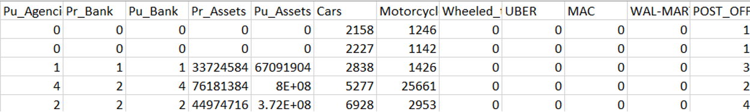

**Business Questions**

* What is the average order fulfillment time for each channel in each store segment?
* What is the revenue generated in store segments in each city?
* What is the revenue generated by each store branch in each city?
* What is the order cancellation percentage for each store?
* What is the total order delivery fee charged by drivers in each city?
* What is the percentage of online transactions as compared to other payment methods?
* What is the average delivery distance an order was carried from a store in each store segment?
* What is the average production time each store requires?

**Abstract**

With the advent of cloud kitchens and restaurants opting for online delivery methods, businesses need a way to keep track of their revenue through various channels. To dive deep into the application of data warehousing in the food delivery industry, I chose to work on a Brazilian delivery center data. The dataset that I found is not optimized to business needs and therefore makes it perfect to explore various weaknesses in their database and present a pure business-oriented design so that they can work efficiently on their data.

**Proposed Data Warehouse Schema**

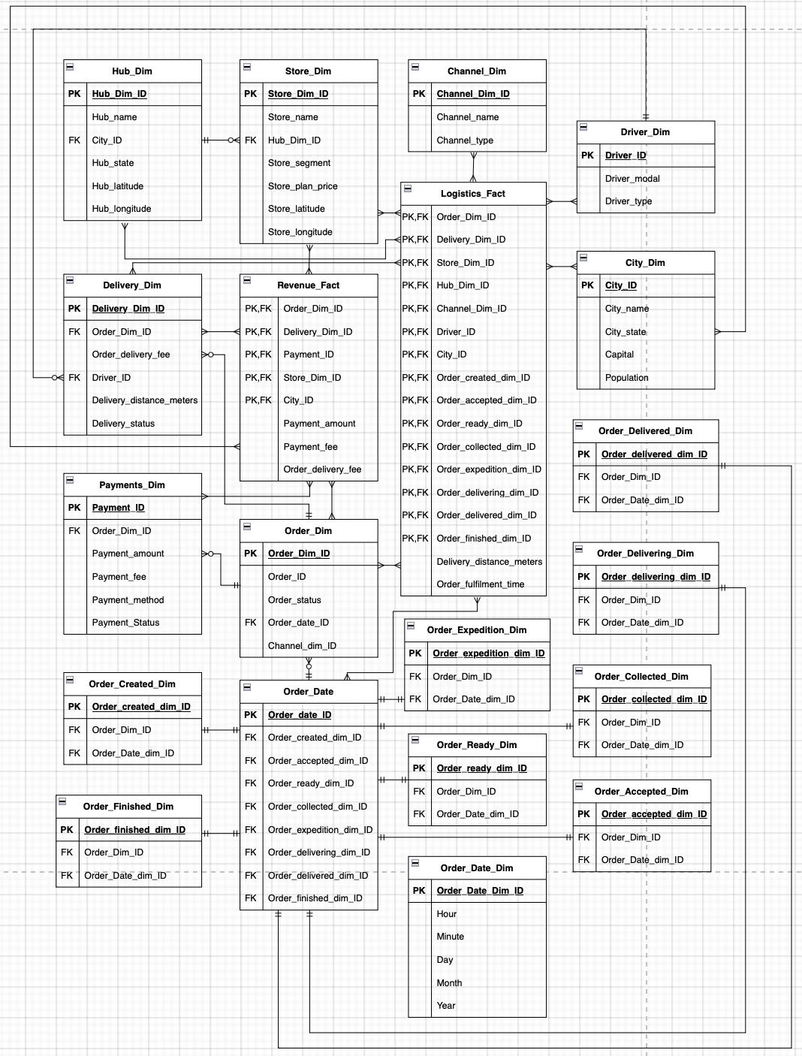

**Extract Phase**

Staging Table: Orders_staging

Loading the delivery center dataset into a data frame.

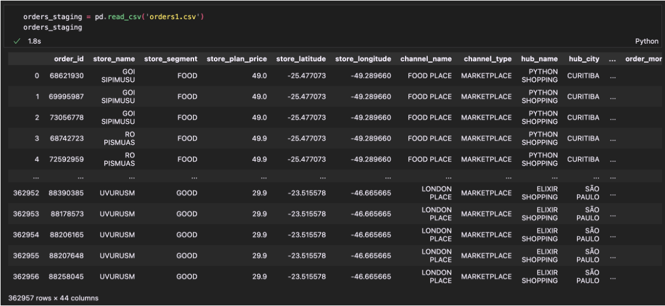

**Transformation Phase**

* In the Orders_Staging table, we notice that there are multiple timestamp attributes like order_moment_accepted, order_moment_ready, order_moment_delivered etc.
* Basically, these denote the timestamps of various stages through which an order is fulfilled.
* Now, when we have to calculate certain measures for analysis, it is better to have every component of the timestamp in a separate column.
* Hence, we perform a transformation on these attributes using a python function.

Python Code used for Date Transformation:

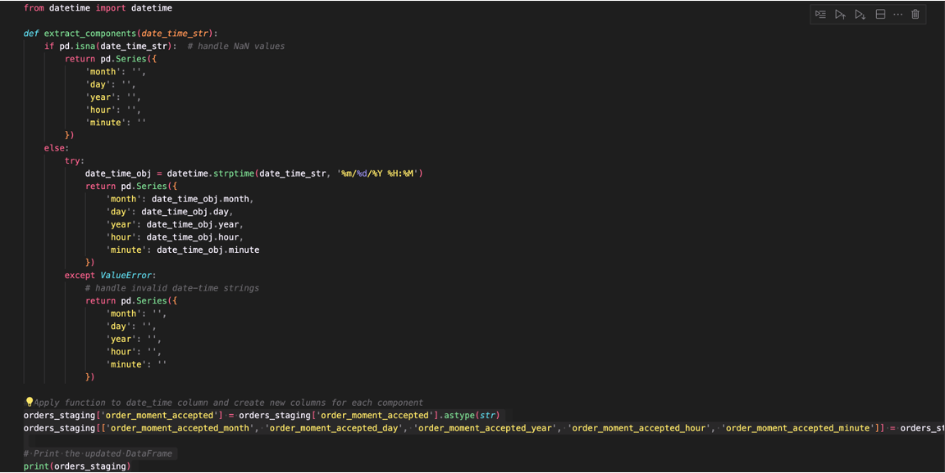

Attributes prior to and after Transformation:

Before:

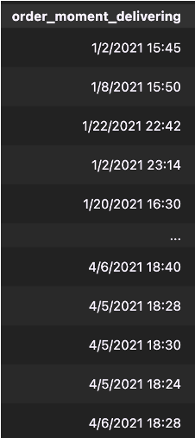

After:

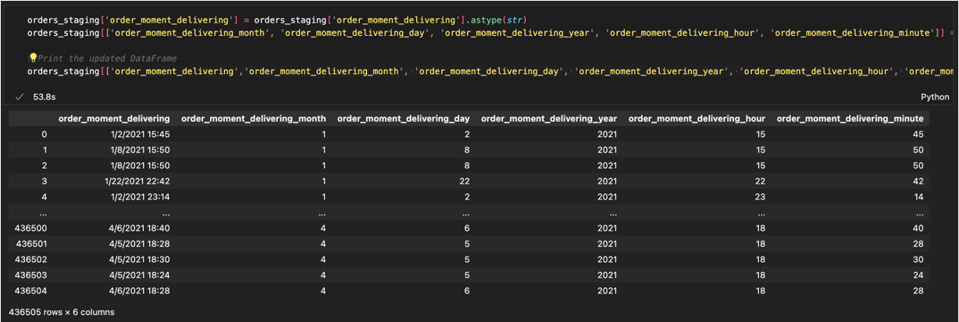

**Dimension Generation**

* If we look at our staging table, we can see that all the aspects of the dataset are just presented through attributes without any IDs or references.
* Therefore, we need to break down individual aspects into different dimension tables.
* For example, Store Dimension will contain attributes pertaining to the store details. These attributes include Store Name, Store Segment, Store Plan Price, Store_Latitude, Store Longitude.
* So, the way we break down each dimension is first subset the dataframe for relevant attributes and store them in a different dataframe and from there assign dimension IDs to uniquely save the details.

Example: Store Dimension Breakdown

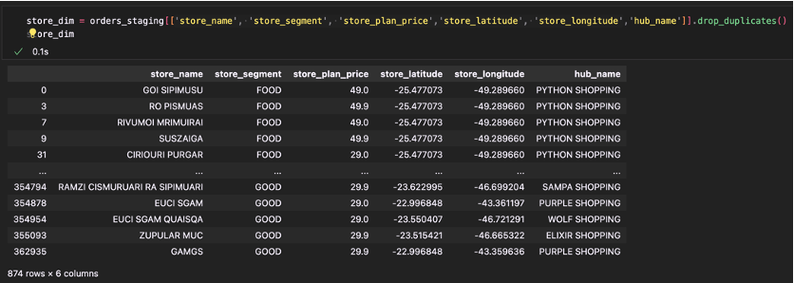

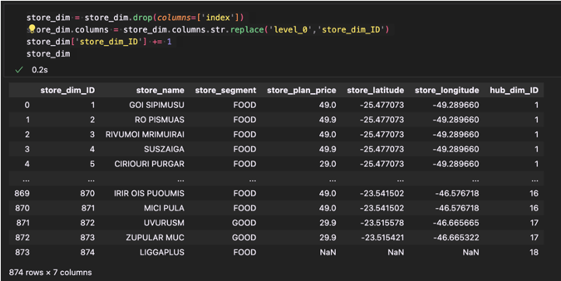

Other Dimensions:

Channel Dimension -

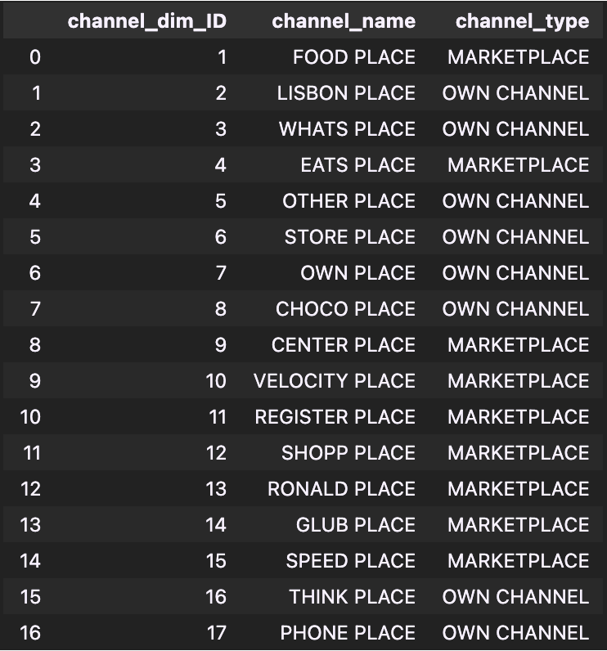

Orders Dimension -

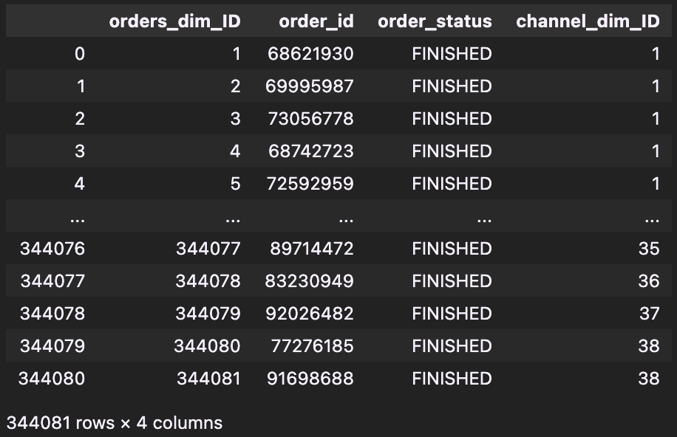

Payments Dimension -

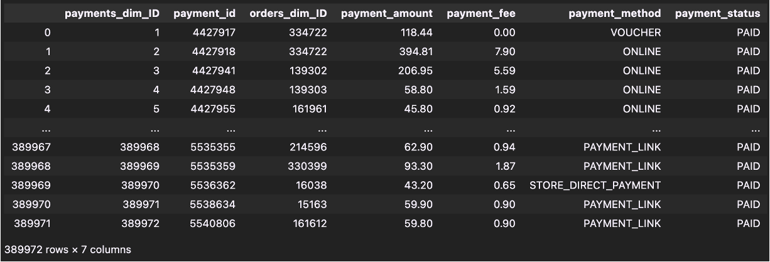

Delivery Dimension -

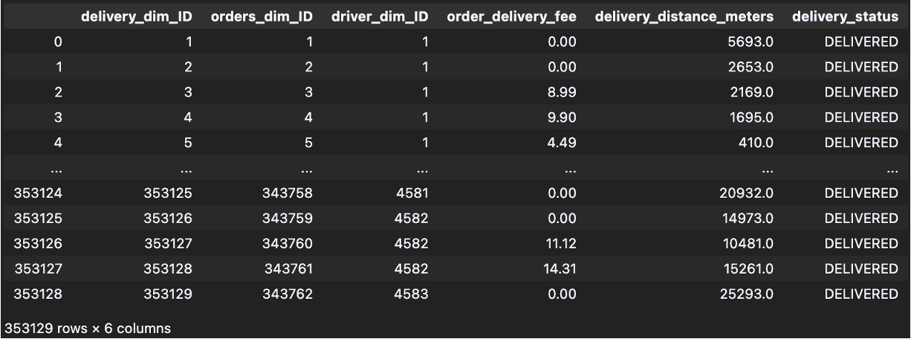

Driver Dimension -

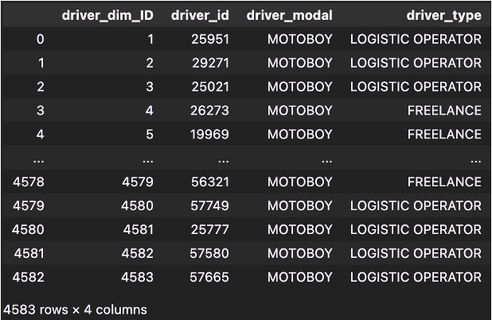

City Dimension -

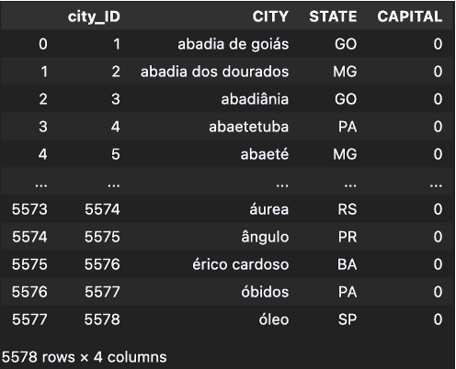

Hub Dimension -

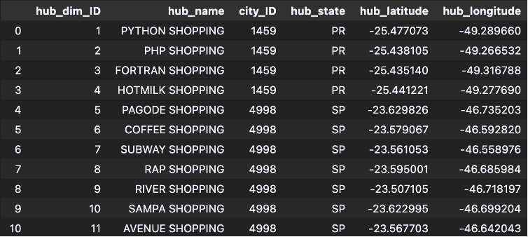

**Slowly Changing Dimensions (SCD)**

Deciding which dimensions need the historical data to be stored, I decided to allot SCDs –

* Orders Dimension – SCD Type 2
  + Order details like order status, order amount etc. change all the time. Therefore, having a record and timestamp of when the data changes is key for the functioning of the warehouse.
* Payments Dimension – SCD Type 2
* Delivery Dimension – SCD Type 2
* Driver Dimension– SCD Type 3
  + Historical Driver information is not important to us. Only the previous and the current data is relevant for business analysis.
* Store Dimension – SCD Type 1
  + Store details rarely change. Therefore, a simple overwrite will serve us the purpose.
* Hub Dimension – SCD Type 1
* Channel Dimension – SCD Type 1
* City Dimension – SCD Type 1
* Order_Moment Dimensions – No SCD
  + I decided on this because if we want to update a record, we will just simply add a new record without updating the previous one.

Delivery Dimension (SCD Type 2):

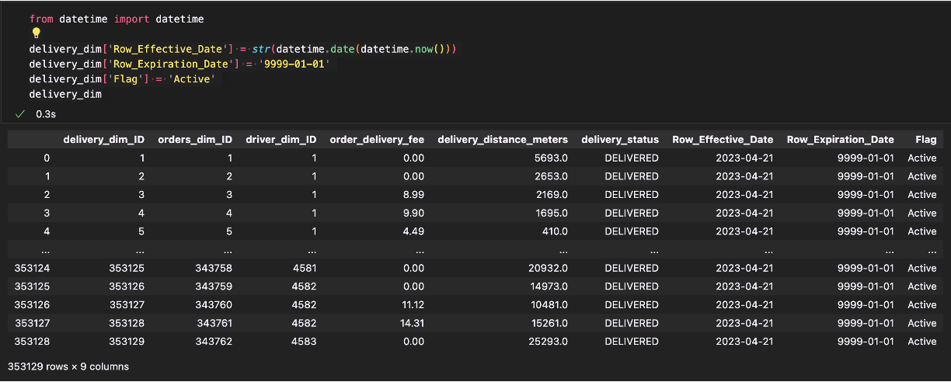

Orders Dimension (SCD Type 2):

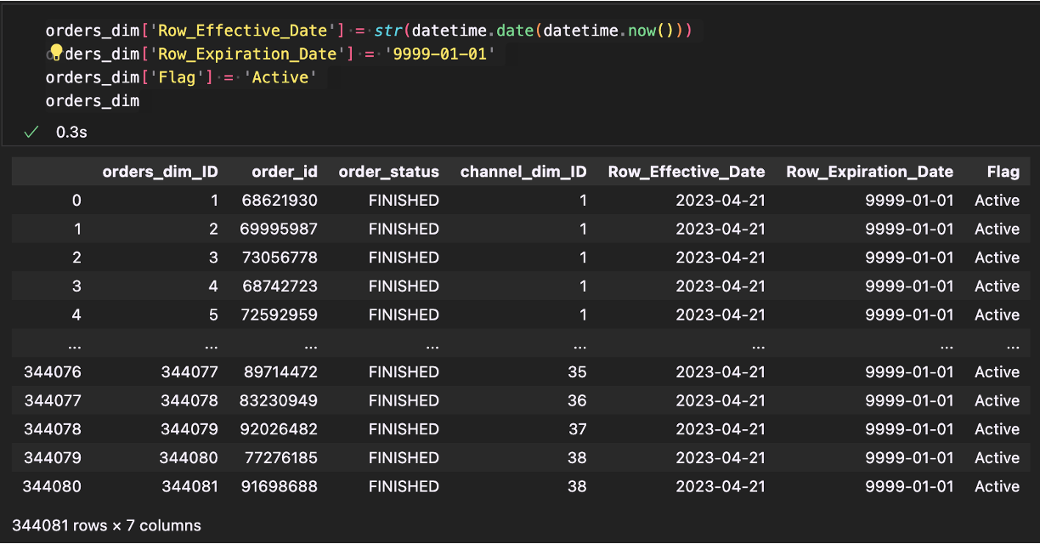

Payments Dimension (SCD Type 2):

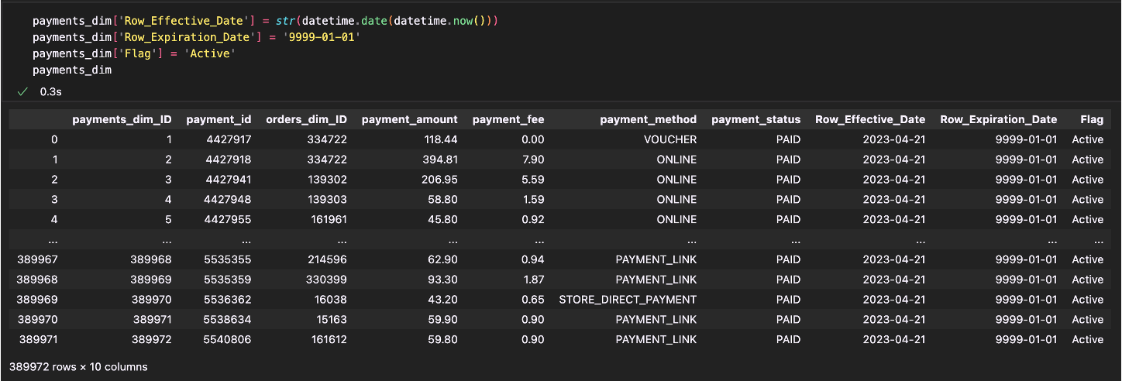

Driver Dimension (SCD Type 3):

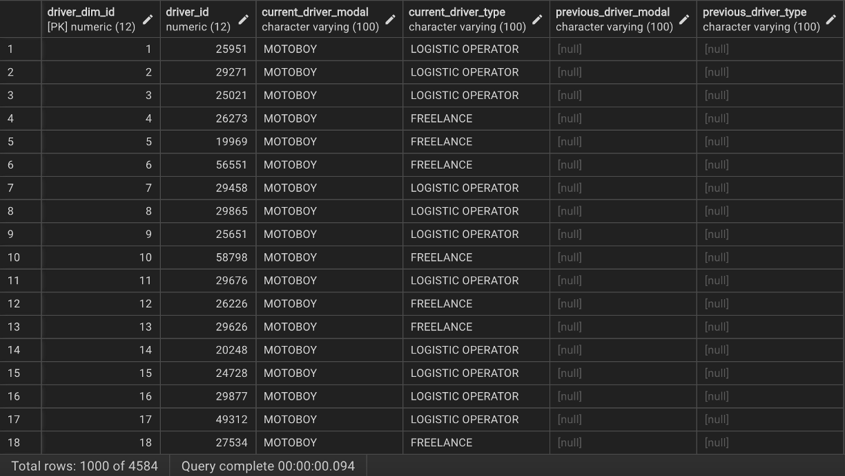

**Fact Table**

Revenue Fact -

* This table contains attributes related to money. For example, payment amount, payment fee, order delivery fee.
* The purpose of the fact table is to help the company analyze different revenue streams along with the costs they have to bear to maintain their channels, hubs, drivers and stores.
* Attributes: orders_dim_id, delivery_dim_id, payments_dim_id, payment_amount, payment_fee, order_delivery_fee, store_dim_id, city_id
* Table formed by merging orders_staging with the relevant dimensions.
* Cumulative Fact Table
* No new derived or transformed measures

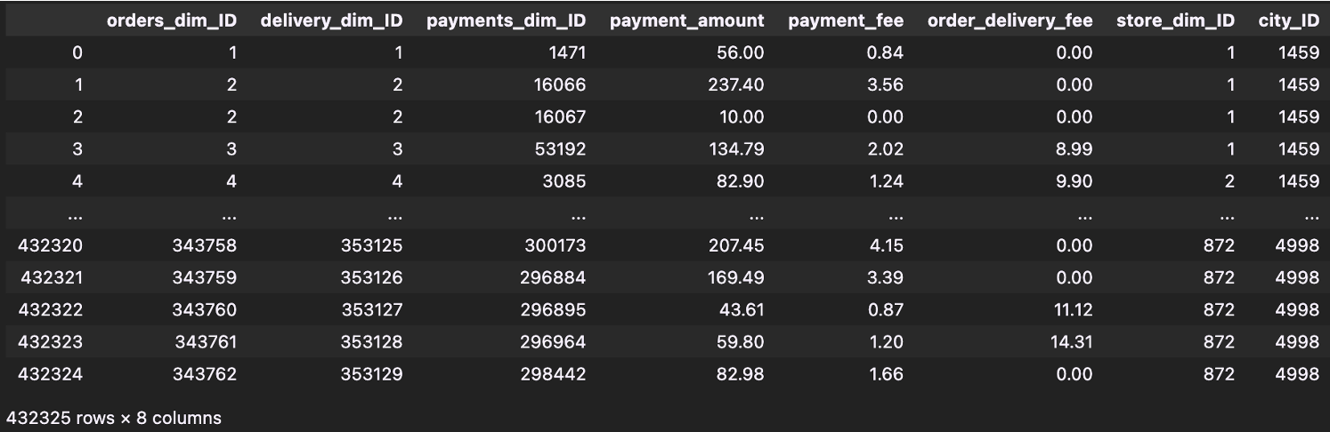

Logistics Fact -

* This table contains attributes related to time and distance. For example, order moment accepted, order moment finished, delivery distance in meters, order fulfillment time.
* This table’s goal is to provide analysis on how much time it takes for orders to be fulfilled along with the distance travelled for the orders to reach their customers.
* Attributes: orders_dim_id, delivery_dim_id, store_dim_id, hub_dim_id, channel_dim_id, driver_dim_id, city_id, order_moment_ids, order_metric_ids, delivery_distance_meters, order_fulfillment_time(derived), order_fulfillment_time_in_minutes(derived)
* Numerous derived measures
* Snapshot Fact Table
* Formed by merging orders_staging with all the dimensions in the proposed schema

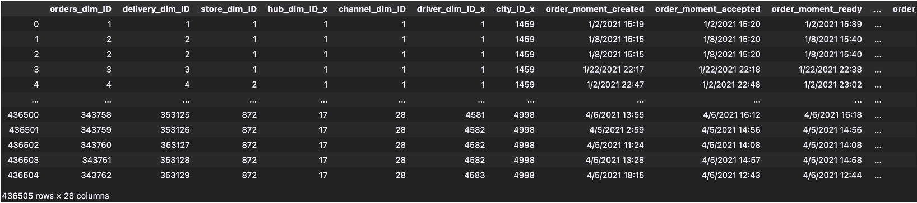

**Generating Derived Measures**

* Once all the attributes were loaded into the fact table from order staging, I wanted to calculate the order fulfillment time.
* So, to do this, I subtracted the order_moment_accepted_time with order_moment_finished_time.
* This gave me a timedelta type column.
* I further broke down this column into days, hours, minutes columns and made a new column with order fulfillment time only in minutes.

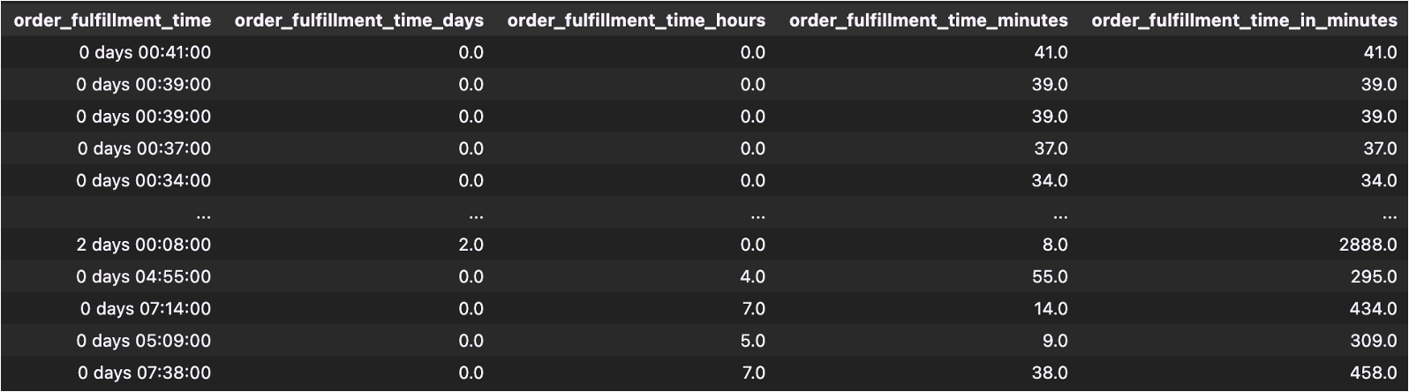

**Loading Phase**

* After all the tables were in place, Dimensions and the fact tables were loaded into postgresql database.
* Sample code of loading the revenue_fact table:

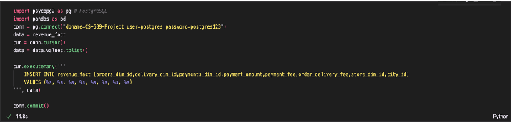

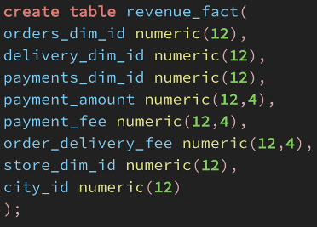

**Maintaining SCDs**

SCD Type 2 (Delivery Dim):

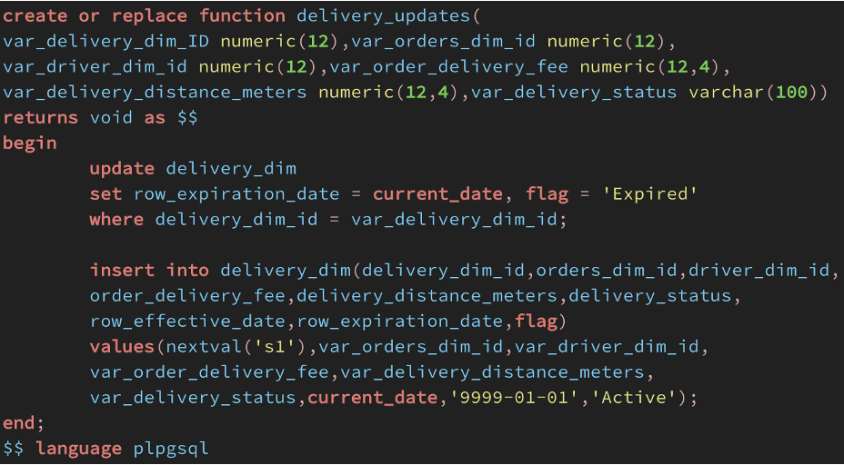

Before Update:



After Update:



As you can see in the above screenshots, before updation, the row expiration date for the original record is 9999-01-01 and as soon as the update is made i.e., delivery status changed from delivering to delivered, previous row expiration date is replaced by today's date and the previous record’s flag is set to Expired.

SCD Type 3 (Driver Dimension):

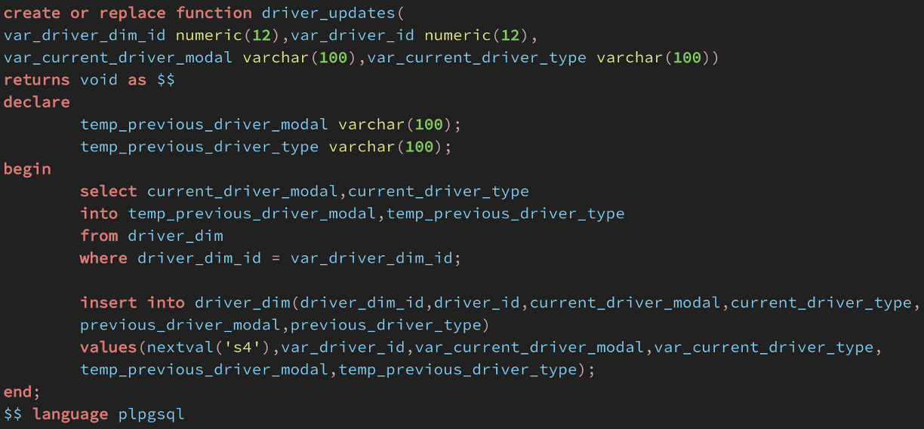

Before Update:



After Update:



**Answers to the Business Questions**

What is the average order fulfillment time for each channel in each store segment?

SQL Code:

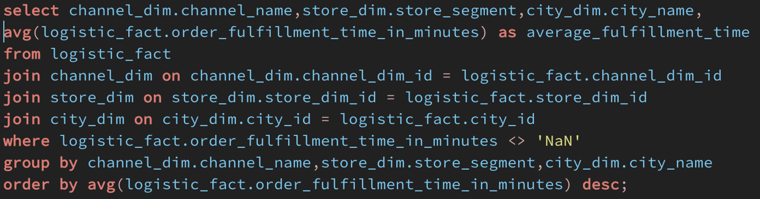

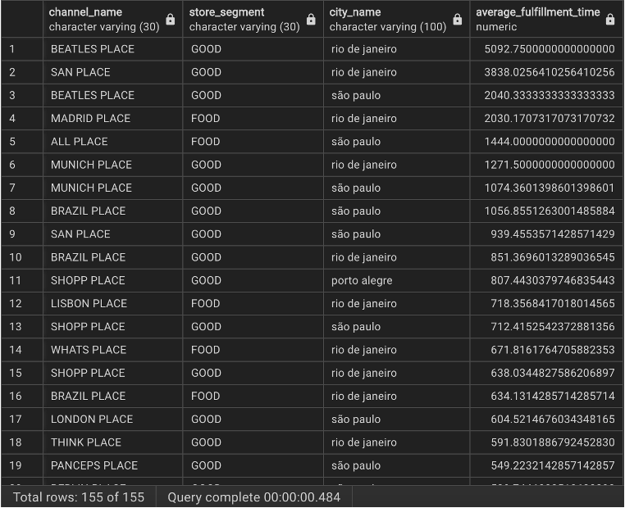

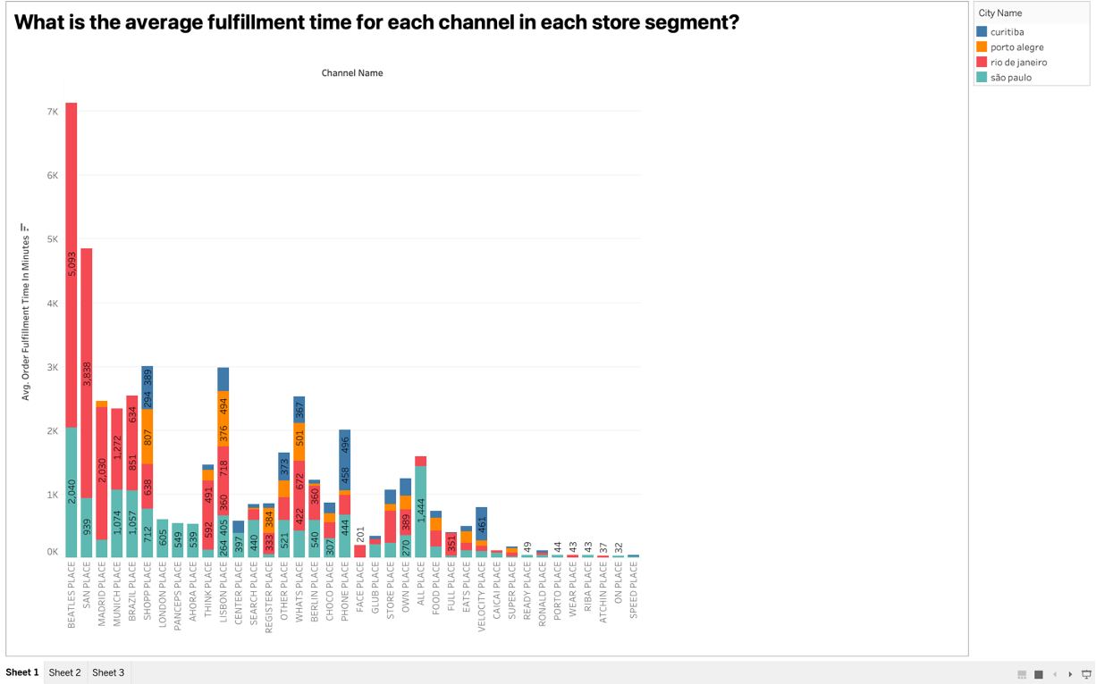

The above visualization shows the average fulfillment time of orders for each channel in each store segment. The different colors on the bars denote different cities and the numbers on the bars show the average order fulfillment time for that particular partition of channel and city.

What is the revenue generated in store segments in each city?

SQL Code:

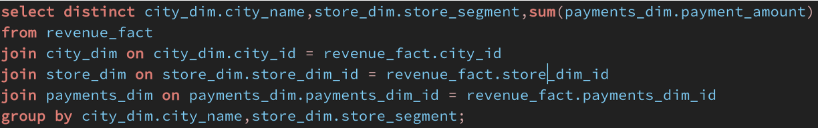

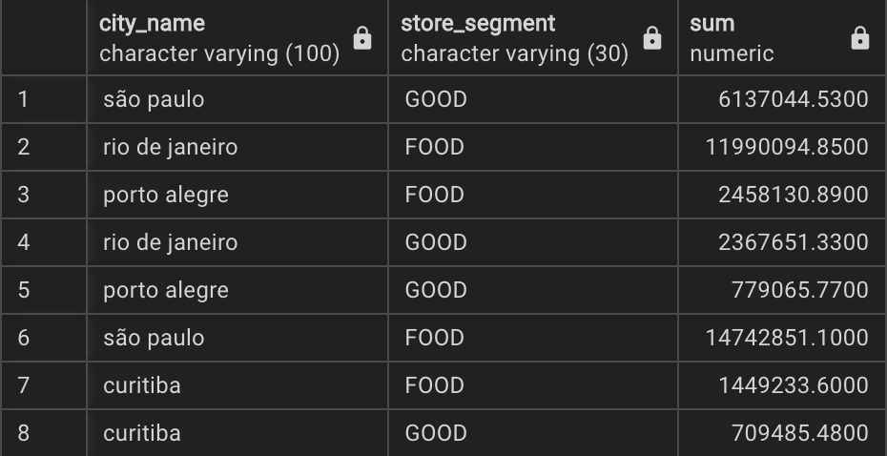

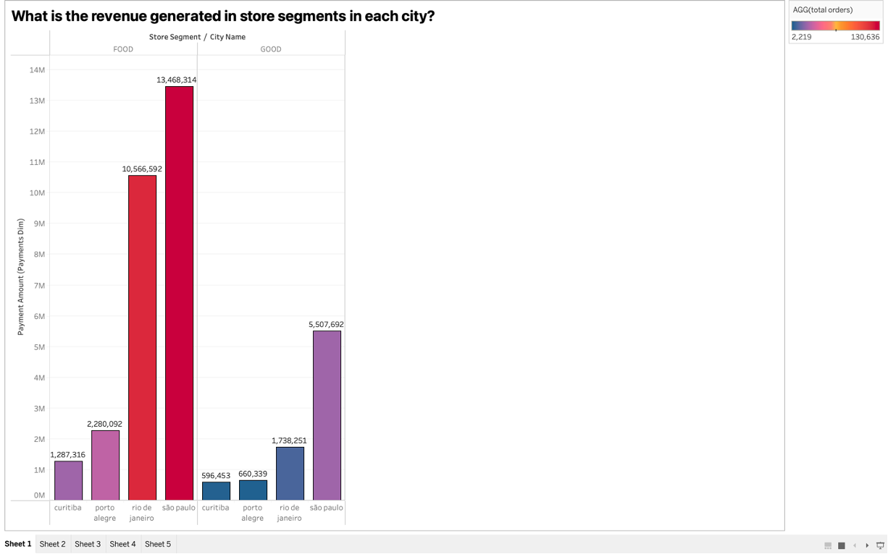

This visualization shows the revenue generated with the food segments on the upper column and the cities on the lower column. The color is of great significance here. Darkest Red color denotes the highest number of total orders received by that city in that segment while darkest blue the lowest.

What is the revenue generated by each store branch in each city?

SQL Code:

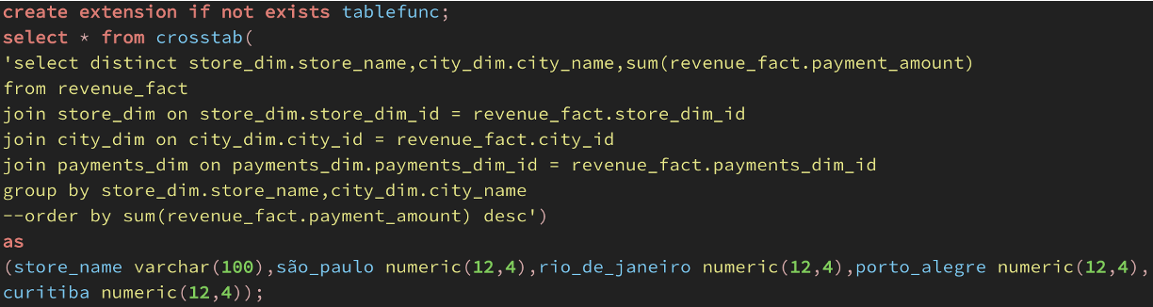

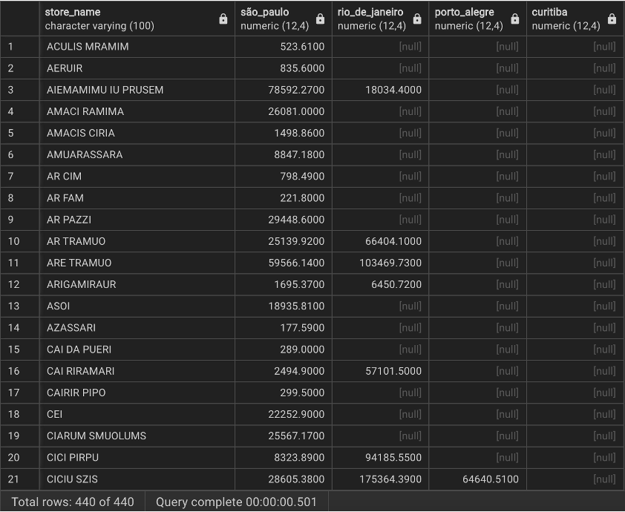

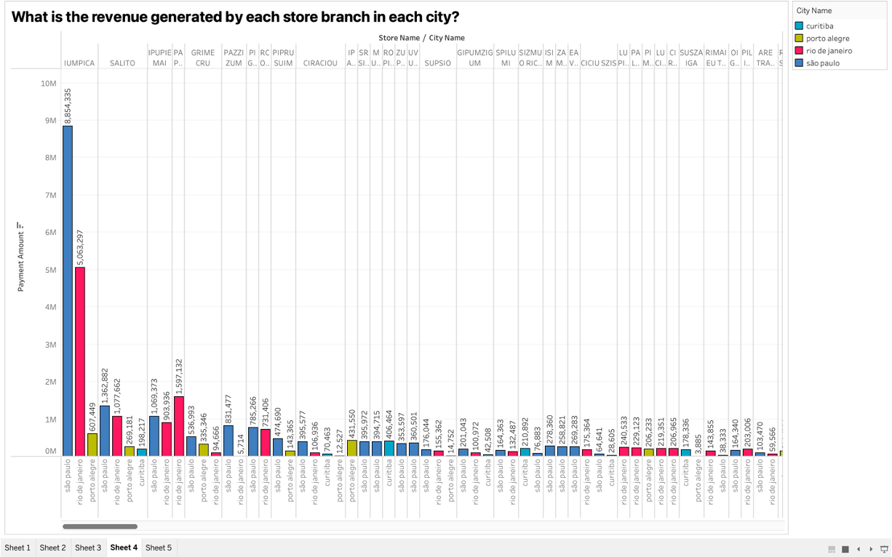

A bar chart with three attributes where the upper column signifies store names and the lower column represents the cities. This was necessary because I wanted to find a side-by-side comparison of how different branches of the same stores perform. The numbers on the graphs are the total revenue generated by that specific store in that specific city. This was done by aggregating payment amounts having the payment status as paid. The colors on the bars tell us which city they belong to although we don't really need that as city names are mentioned below but still for a visual appeal, I included them.

What is the order cancellation percentage for each store?

SQL Code:

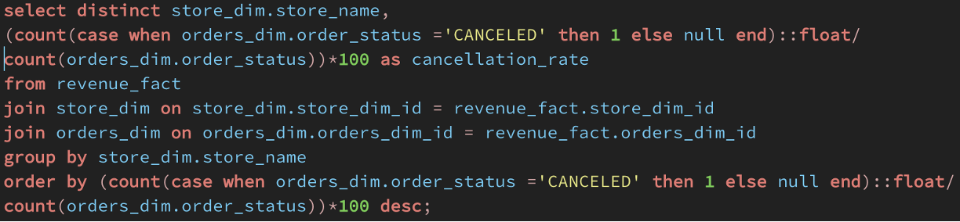

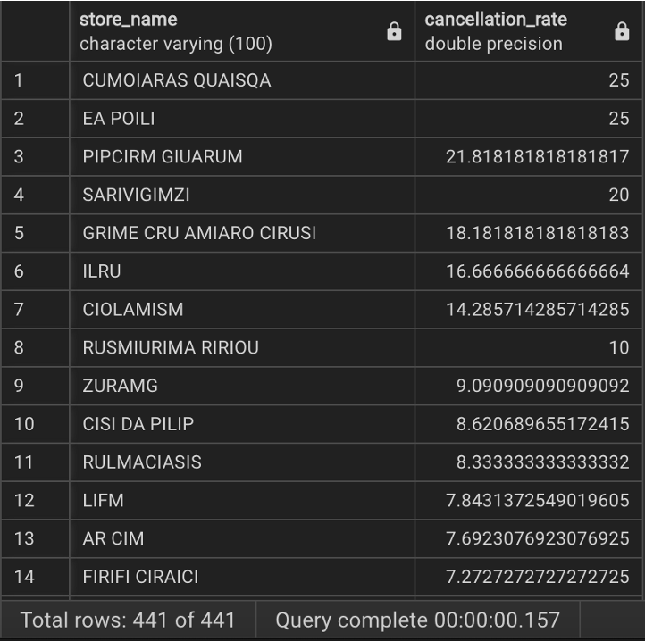

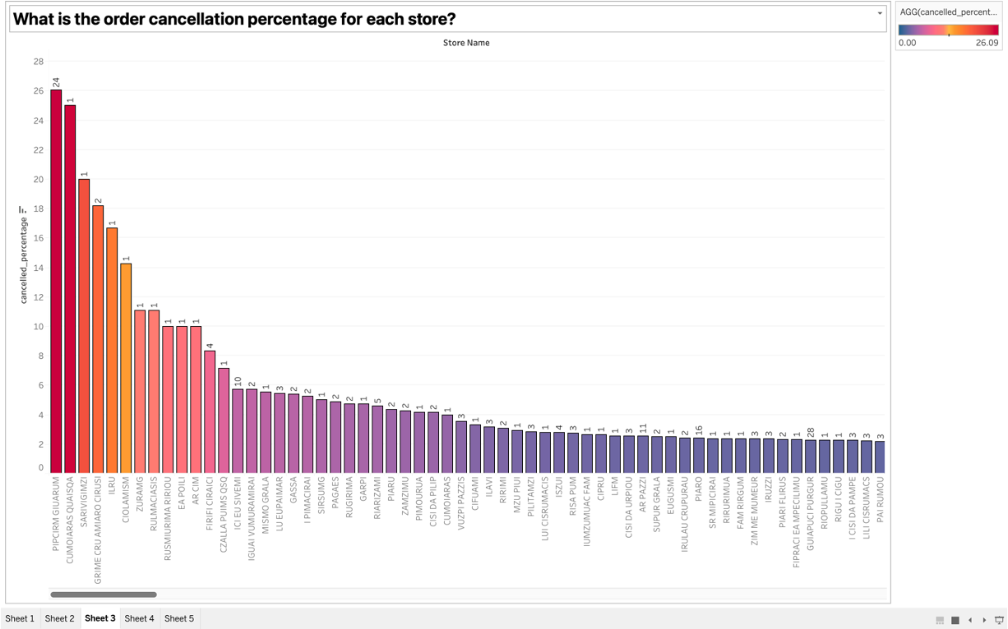

The thickness of the colors represents the cancellation percentage. Dark red is a higher percentage while dark blue the lowest.

What is the total order delivery fee charged by drivers in each city?

SQL Code:

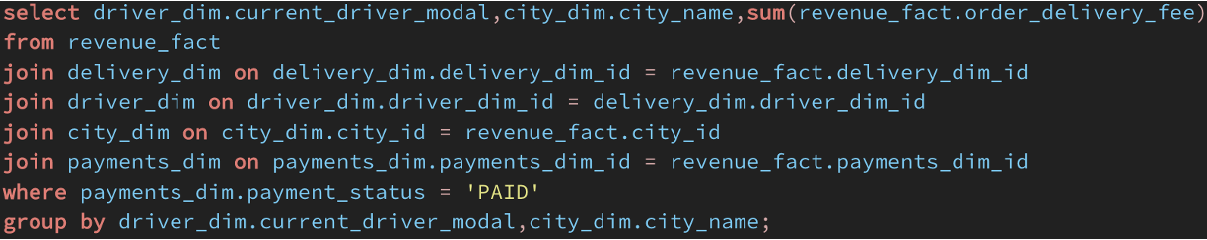

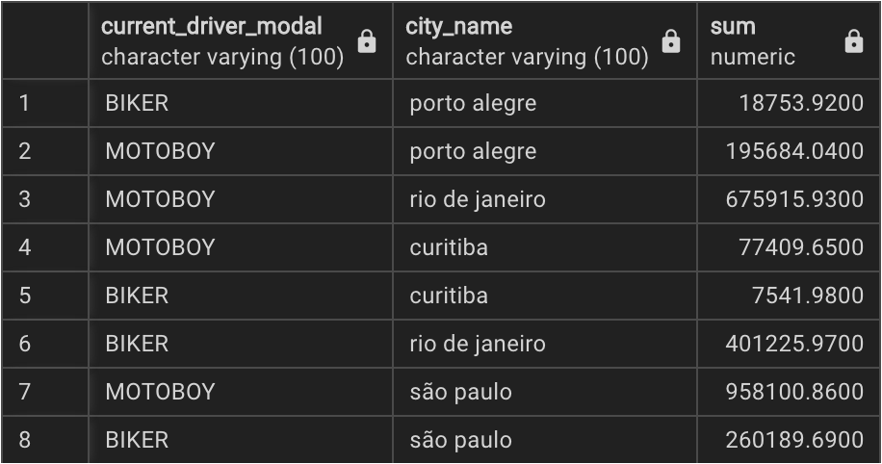

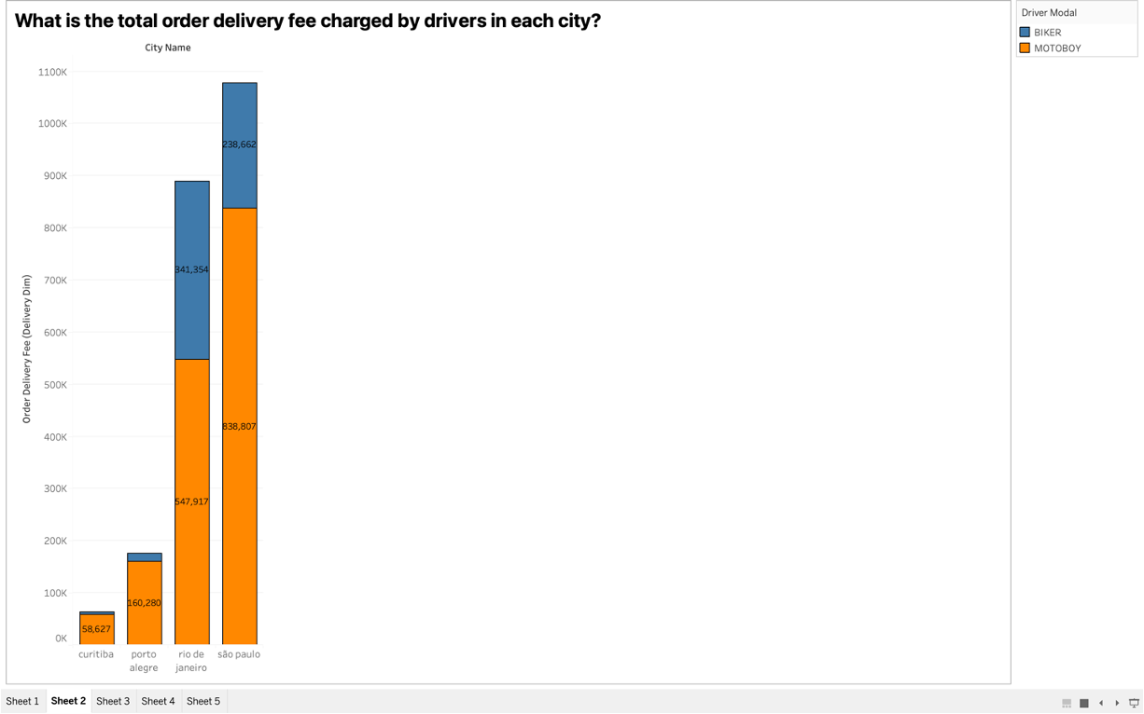

The visualization differentiates between the delivery fee charged by Bikers and MotoBoys in different cities. Blue denotes Bikers while Orange denotes MotoBoys.

What is the percentage of online transactions as compared to other payment methods?

SQL Code:

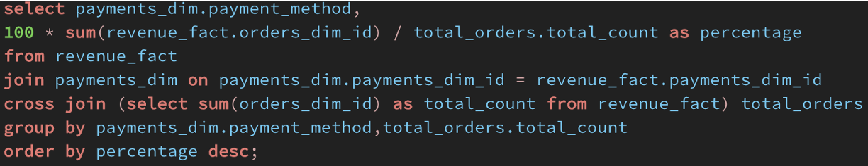

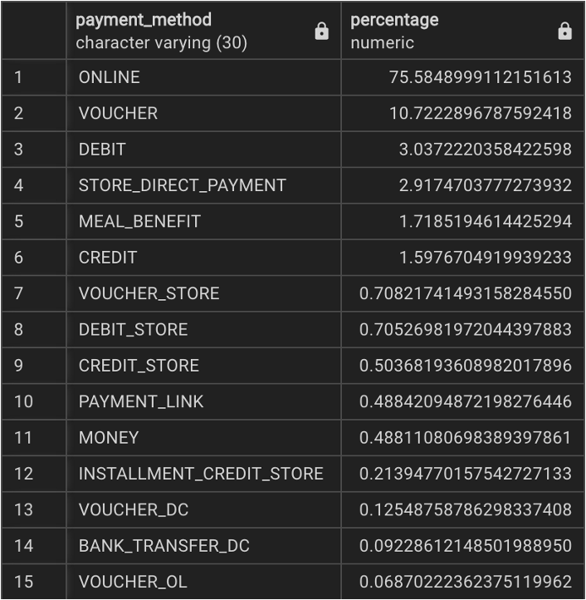

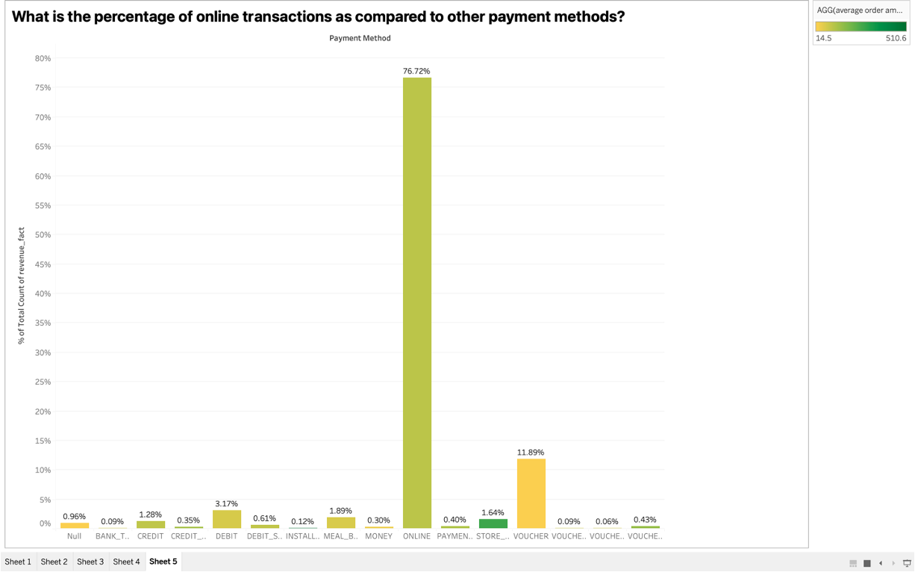

More greener the bar, the more was the average order amount through these payment methods.

What is the average delivery distance an order was carried from a store in each store segment?

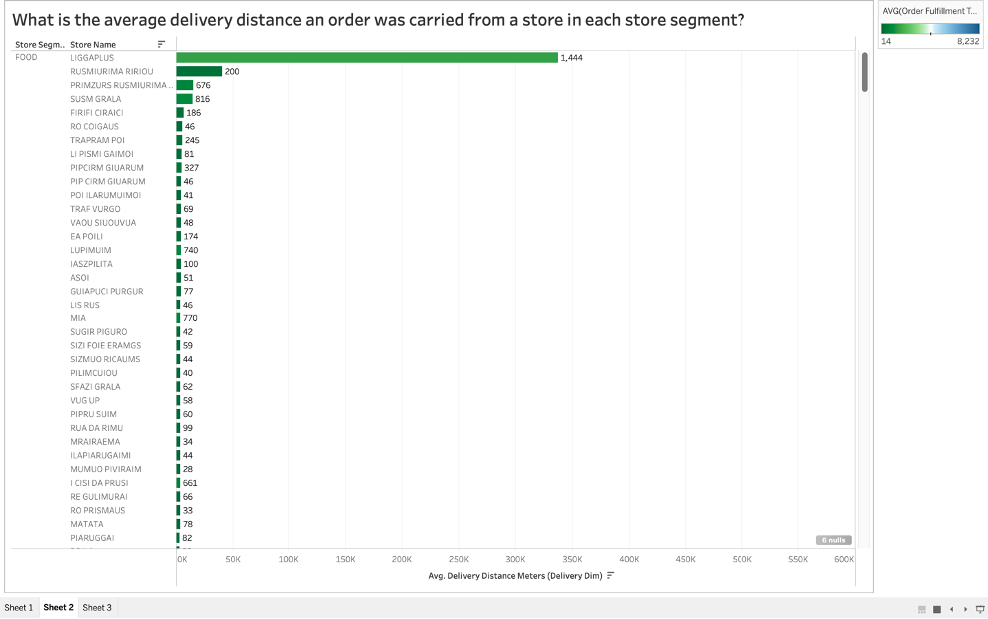

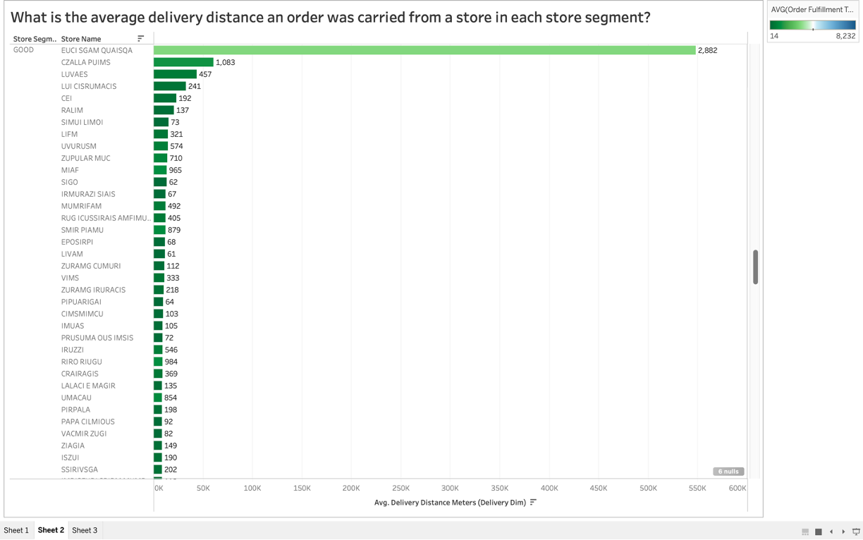

This visualization is a horizontal bar graph which measures the average distance a driver had to travel to fulfill an order. In general, the Goods segment had a higher average distance than the food segment. Darker Green bars denote the lower average fulfillment times while Darker Blue the higher.

What is the average production time each store requires?

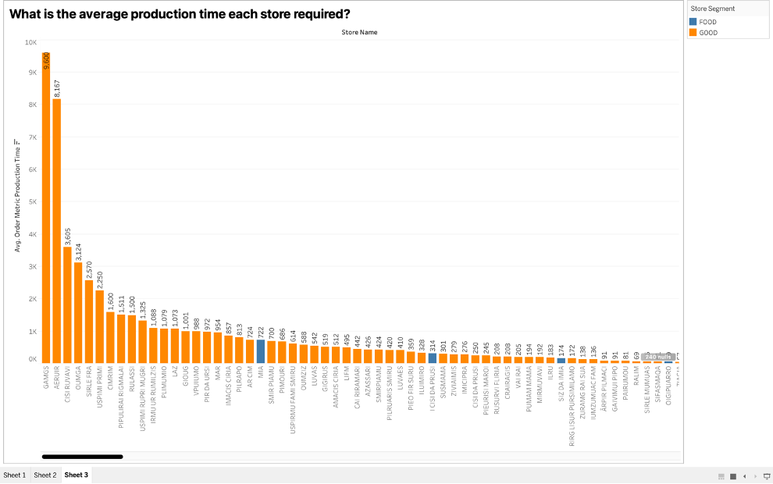

This visualization proves that the production time required for the Goods segment is significantly more than the food segment. This was proved when we obtained more orange bars (i.e. Goods segment) in the visualization when sorted in descending order of production time.